Order Received (In-Person Delivery)


If you receive an in-person delivery order that you need to approve, skip to step 2.

If the order isn’t approved by midnight, you will receive an email from email@email.girlscouts.org with the subject “Action required: you have an in-person delivery request!” letting you know your Girl Scout has received an order for delivery. Hooray!

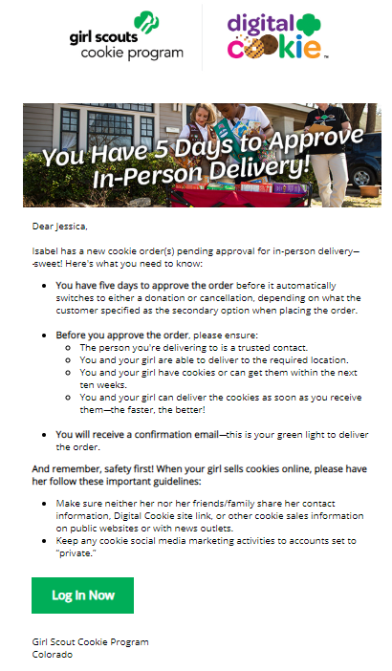


Click the green button “Log In Now” in the email. That will take you to the Digital Order Card website where you can log in. Or, go to the Digital Cookie website and log in.

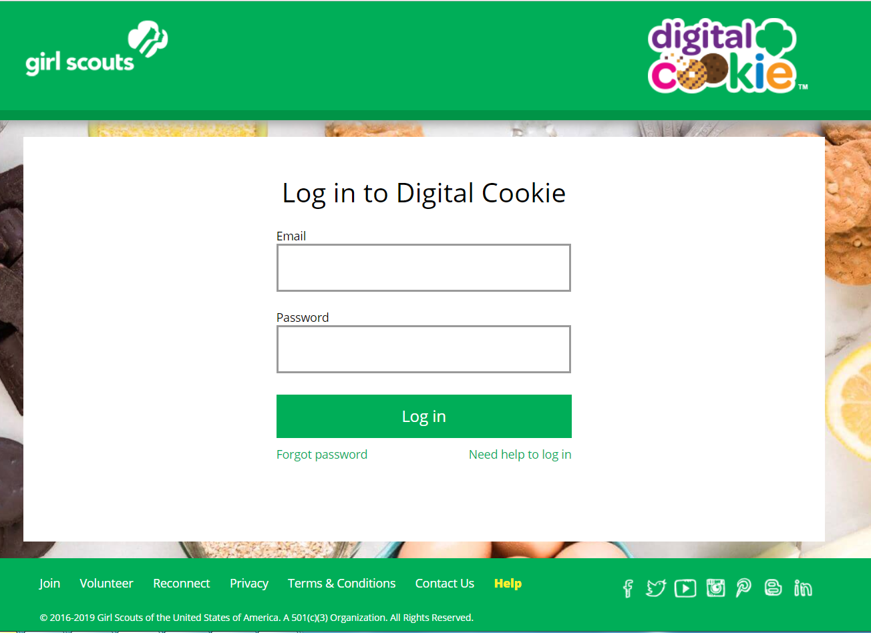

Click on the “Orders” tab and see what orders are pending your approval.




You will see a list of all orders needing approval, including the customer order number, number of boxes in each order, the customer’s address, when the customer placed the order, and the number of days you have to approve it until it reverts to the customer’s second choice option.

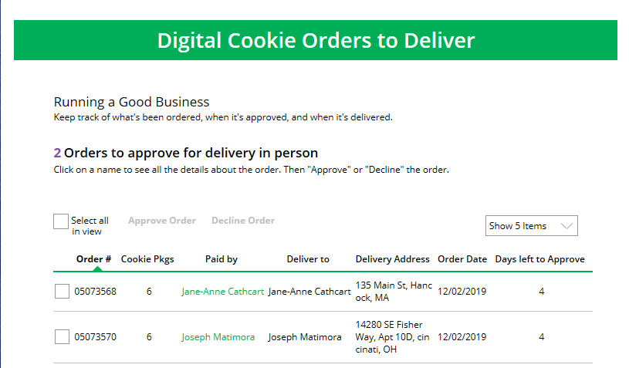

TIPS!
- The customer’s second choice could be “Cancel” or “Donate.” Don’t risk a lost sale and a disappointed customer—approve or decline orders within ten days.
- Be sure to approve the order before delivering it to make sure the customer’s payment is accepted.
TIPS!
- The customer’s second choice could be “Cancel” or “Donate.” Don’t risk a lost sale and a disappointed customer—approve or decline orders within ten days.
- Be sure to approve the order before delivering it to make sure the customer’s payment is accepted.

When determining whether to approve or decline the order, consider -


- Is the customer a known and trusted individual?
- Are you willing and able to get the cookies to the customer’s location in the next ten weeks?

AND
- Do you have or will you have the inventory available?

If so, “Approve Order.”

If you are unable or unwilling to fulfill the customer’s order, click “Decline Order” and the order will default to whatever second option the customer has selected: “Cancel” or “Donate.”


There are multiple ways to approve and decline orders for delivery.
- Check the boxes in front of the orders you want to approve or decline and then click “Approve Order” or “Decline Order”
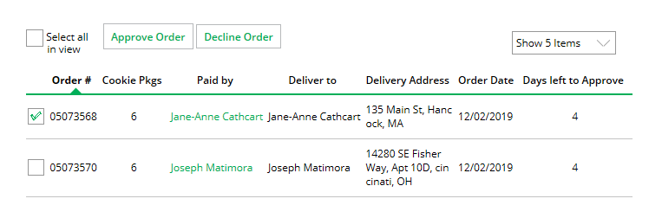

You will get a pop-up message confirming you want to approve all of the orders you selected and can deliver them to the customer:
Once you approve or decline you can’t change the action and an email is deployed to the customer.
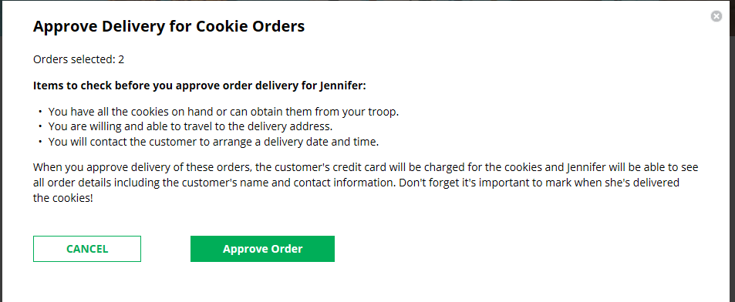

Or that you want to decline all of the orders you selected and understand if the orders are being cancelled or donated:
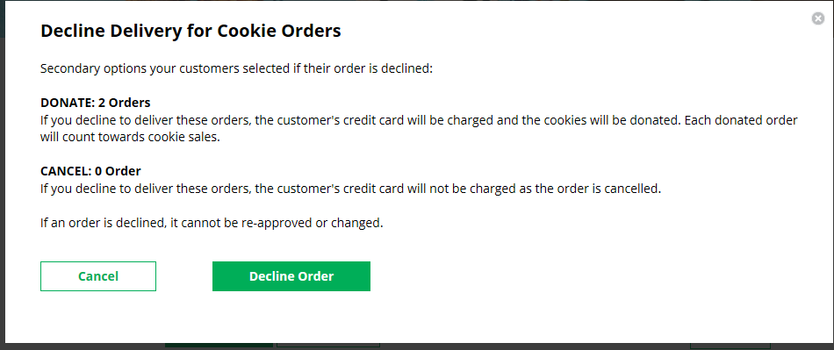
- Click the “Select All” box, which will select all of the orders on that page that need approval, then click “Approve Order” or “Decline Order”.

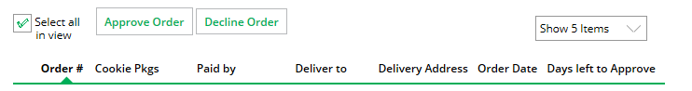

You will also get a pop-up message confirming your batch approval or your declining of the orders selected, as above in option a.

- Click on the individual customer to bring up that person’s order details:

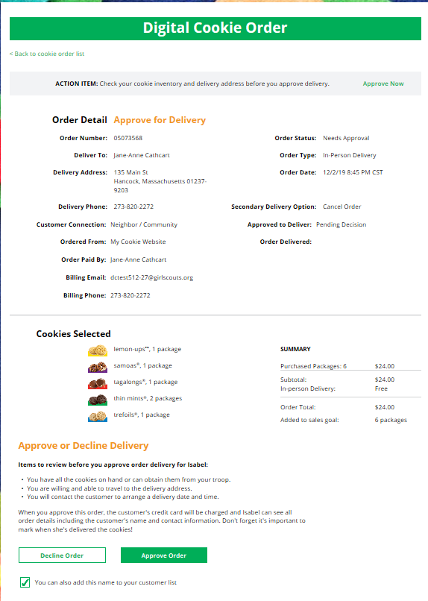

And click “Approve Order” or “Decline Order” at the bottom.


If you have approved the order, it will move down to the section “Deliver: Orders to Deliver”, below the “Approve” section.
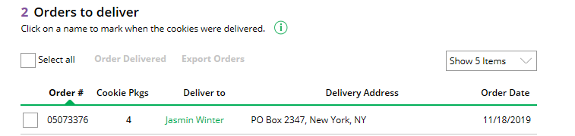



Once you have delivered the cookies, log back into Digital Order Card and mark those orders delivered. There are two ways to indicate you have delivered your order:
1. Check the “Select All” box to select all of the orders on the page; they will all be marked “Order Delivered”.
2. Check the box in front of any orders you have delivered, and then click “Order Delivered.”

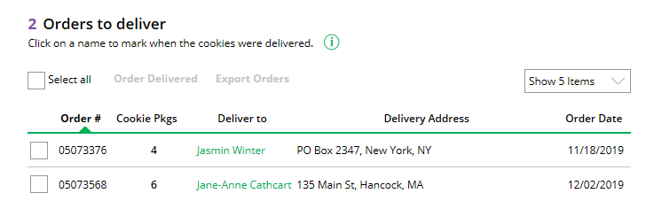
Select a customer
Select all
OR

When they are marked as delivered, they will move down into the third section on the page as a completed order.

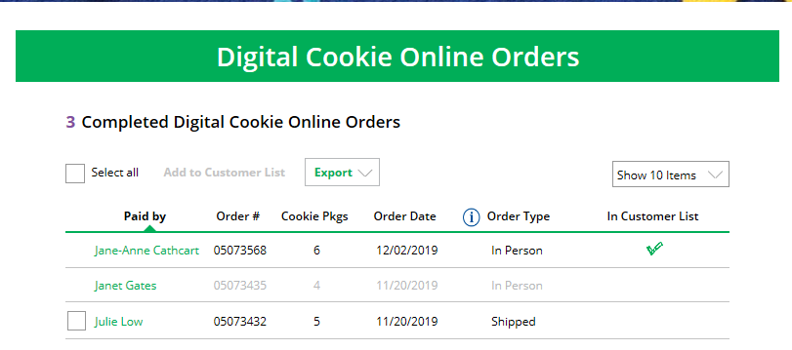

If the customer is not in her Digital Cookie contact list, your Girl Scout can check the box in front of the customer’s name and click “Add to Customers tab.” Then, the customer will be in her records for sending thank-you emails this year and marketing emails next year for repeat business.

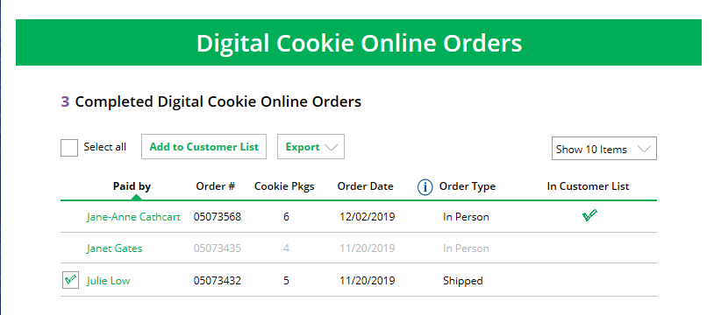
.

Make sure you follow through and deliver those cookies. When you approve the order, the customer will be charged.
Your leader will see the financial transaction as a credit to your Girl Scout in eBudde after you have approved delivering the order.

While in the site checking on orders, girls can add customers, send follow-up emails, complete badge work, or explore the great girl tools on the website. Along the way, your Girl Scout will pick up some good cookie program tips!

